OBSERVATION:
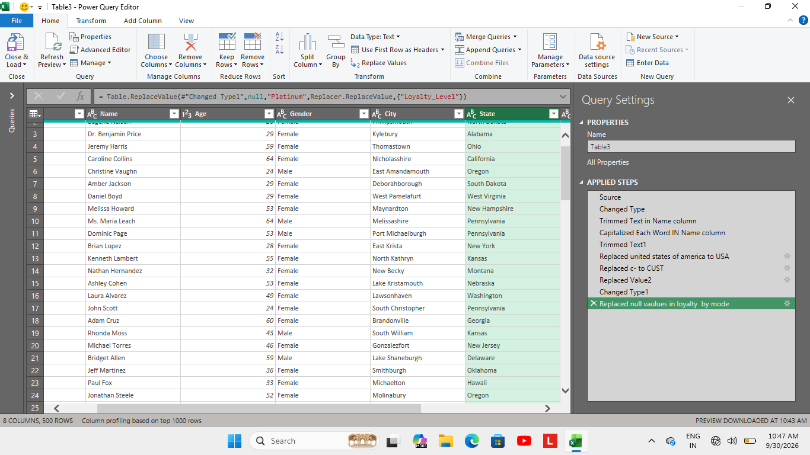
Corrections done in Customer_Dim table:
- Used trim function to unwanted spaces in Name column.
- Used proper function in name column.
- Replaced values c- as CUST, United states of America as USA.
- Replaced null values in loyalty column by using MODE function.
Corrections done in Product Dim table:
- Replaced P- as PROD.
- Found averages values in cost column by category and sub category.
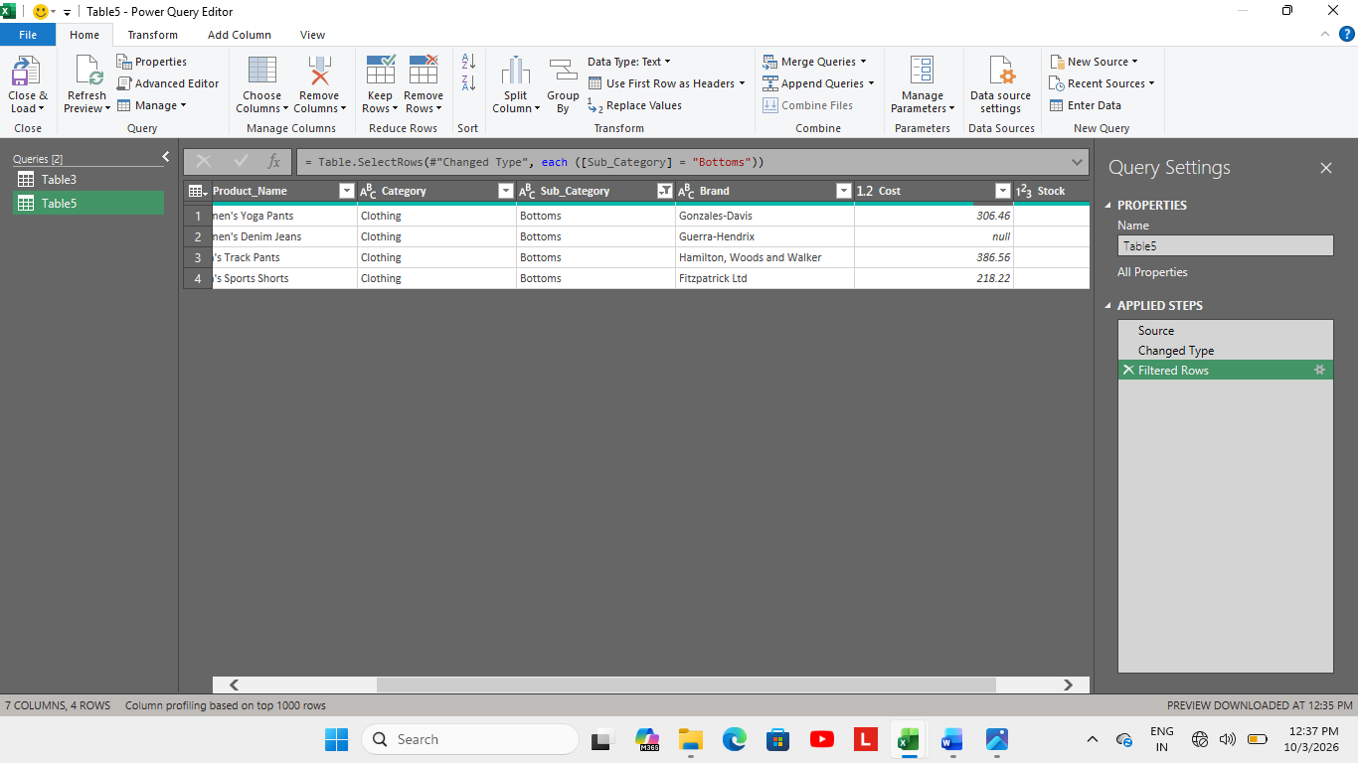
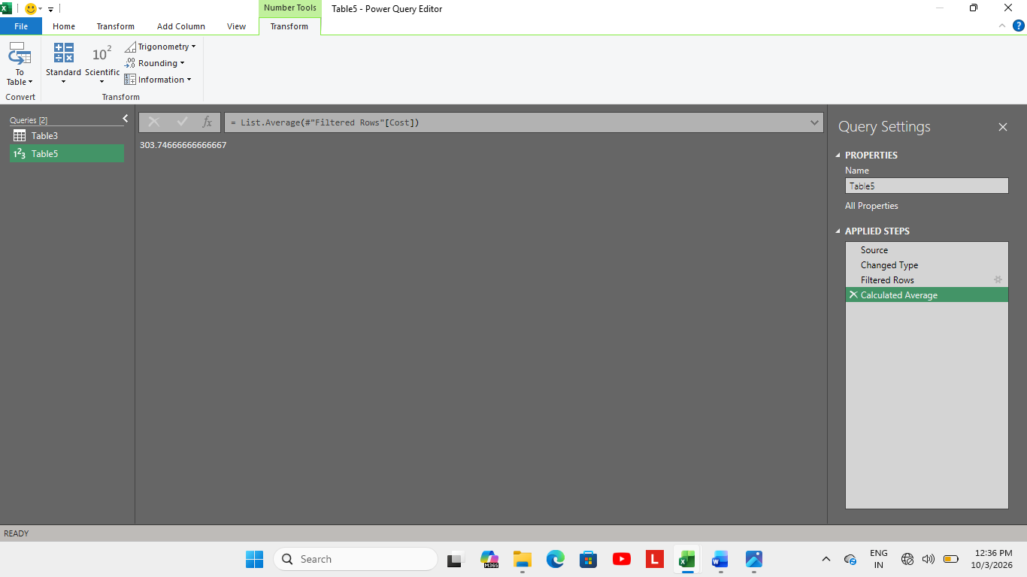
- Used same strategy to find missing values in stock too.
- Added new column as stock value used PRODUCT Function to multiply cost and stock.
Corrections done in Sales Fact table:
- I deleted Sales Id column because I think it is not necessary.
- I used same strategy as mentioned to find average value in quantity, unit price, discount and filled it.
- I formatted date as DD-MM-YYY format.
- I used XLookup Function to add cost price column from product table.
- Added profit column using formula.
Corrections done in Store Dim table:
- I added a column named total sales by store id here I sum upped the total sales done by each store, I used SUMIF Function for that.
- Added total quantity ordered column, total discount allowed column, profit earned column summed up using SUMIF function to know about each store.

- I made Descriptive Statistics for Total amount of Sales vs stock value of products.
- I created pivot tables for store sales, total quantity ordered and profit earned.
- I added all the charts to dashboard and added slicer to it and used report connection to access all charts with that slicer.

